Biographical Sketch

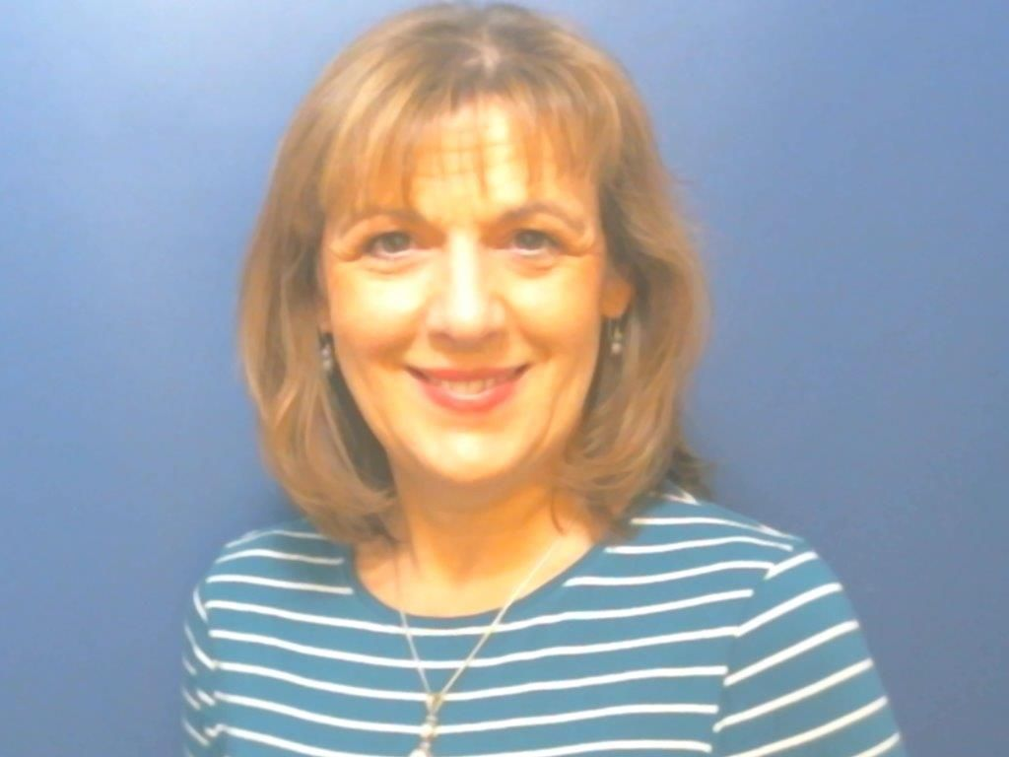



Carolyn Hinds

Dr. Carolyn Hinds is a Consultant Clinical Psychologist, Betsi Cadwaladr University Health Board and Honorary Lecturer in Clinical Psychology, School of Psychology, Bangor University. She is also an accredited Behavioural and Cognitive Psychotherapist in CBT with the British Association for Behavioural and Cognitive Psychotherapy (BABCP).

Dr Hinds has worked clinically with children and adolescents in North Wales since 1990, working full time in Tier 3 CAMHS since 1996. Dr Hinds trained in DBT in 2004 and has delivered it with adolescents presenting with suicidal and self-harming behaviours since then within the Conwy and Denbighshire DBT team. Dr Hinds also has experience of supervising staff within the CAMHS team and Clinical Psychology Trainees on the North Wales Clinical Psychology Programme, Bangor for over 20 years. She has participated in teaching on the North Wales Clinical Psychology Programme, Bangor and has been an internal examiner for the Reports of Clinical Activity and a number of theses in the past 10 years. Dr Hinds is a fluent Welsh speaker, and offers therapeutic work through the medium of Welsh.

Dr Hinds is currently one of the therapists on REFRAMED: Refractory Depression – Mechanisms and Evaluation of DBT, a multi-site MRC funded trial.

