Biographical Sketch
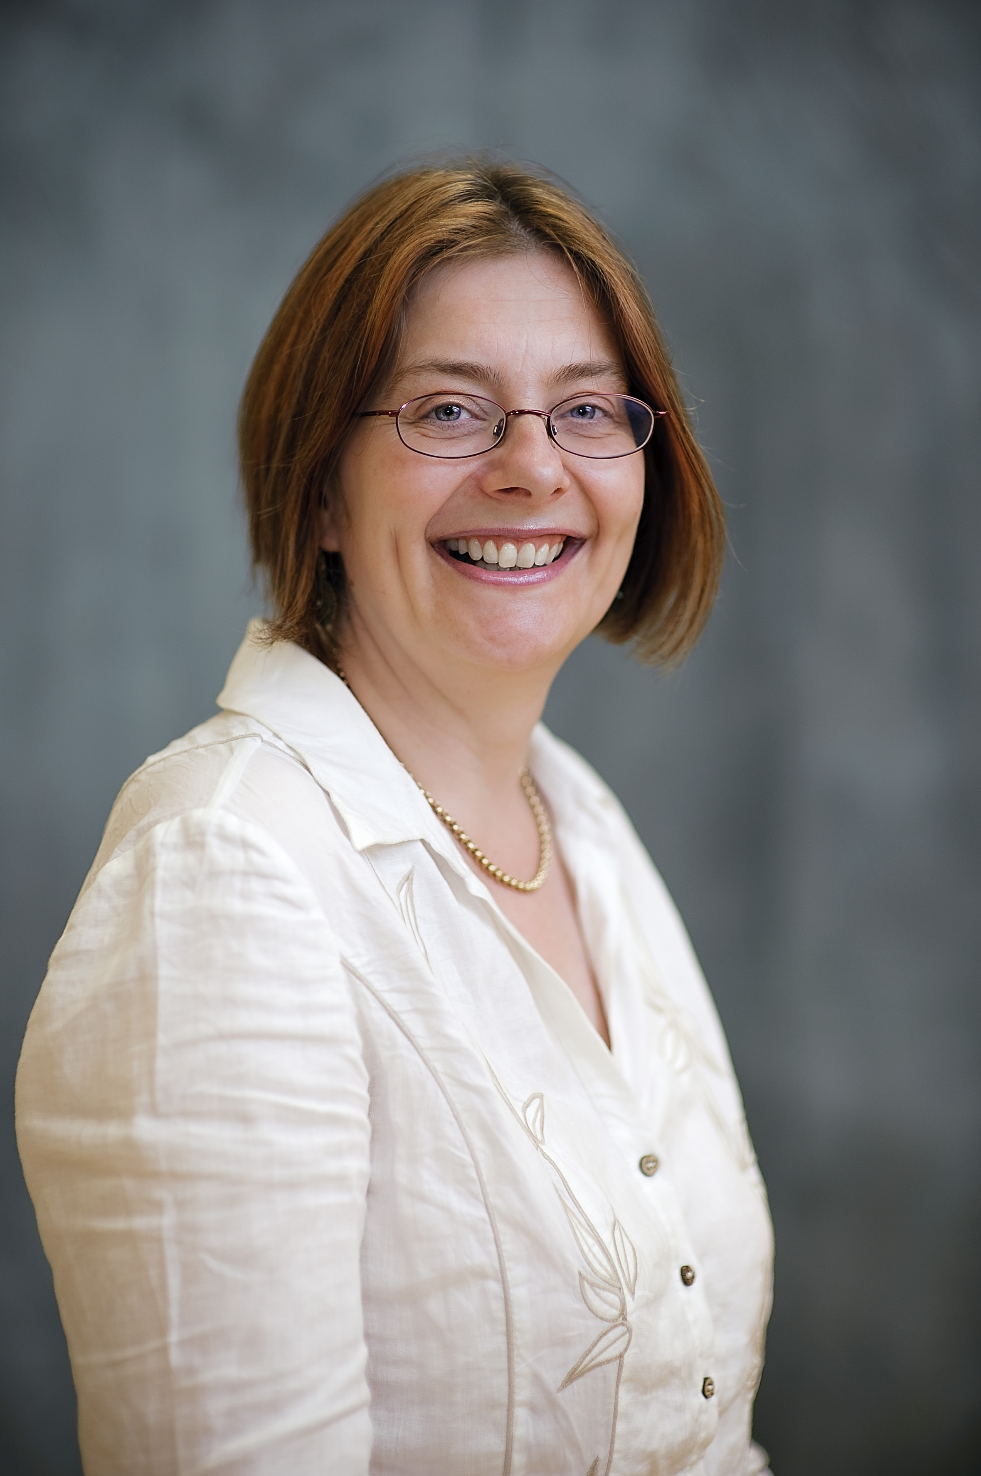

Michaela Swales


Dr. Michaela Swales is Consultant Clinical Psychologist, Academic lead for CAMHS, Betsi Cadwaladr University Health Board and Reader on the North Wales Clinical Psychology Programme, School of Psychology, Bangor University.

Dr Swales worked for 20 years in a regional Tier 4 inpatient service for adolescents serving North Wales. She specialises in delivering a DBT programme for adolescents with suicidal and self-harming behaviours. She completed Intensive Training in DBT in Seattle, USA in 1995 and became the Director of the UK DBT Training Programme in 2002. In this role, she trains staff and consults to programmes in a range of settings with a variety of client groups. As a result of both her clinical work and her role in training, Dr Swales has developed a particular interest in the effective implementation of evidence-based programmes of care. She is co-author, with Dr Heidi Heard of Dialectical Behaviour Therapy in the ‘CBT Distinctive Features Series’ published by Routledge in 2009. She was awarded the Cindy Sanderson Outstanding Educator Award by the International Society for the Improvement and Training in DBT at their conference in New York in November 2009.

Dr Swales was a member of the guideline development groups (GDGs) that, on behalf of the National Institute of Health & Clinical Excellence (NICE), wrote the guideline on the Treatment and Management of Borderline Personality Disorder (2009) and the Longer Term Management of Self-Harm (2011).

Dr Swales participates in the Working Group on Classification of Personality Disorders, which reports to the World Health Organisation (WHO) International Advisory Group for the Revision of ICD-10 Mental and Behavioural Disorders. Dr Swales is Site Principal Investigator on REFRAMED: Refractory Depression – Mechanisms and Evaluation of DBT, a multi-site MRC funded trial.

