Biographical Sketch

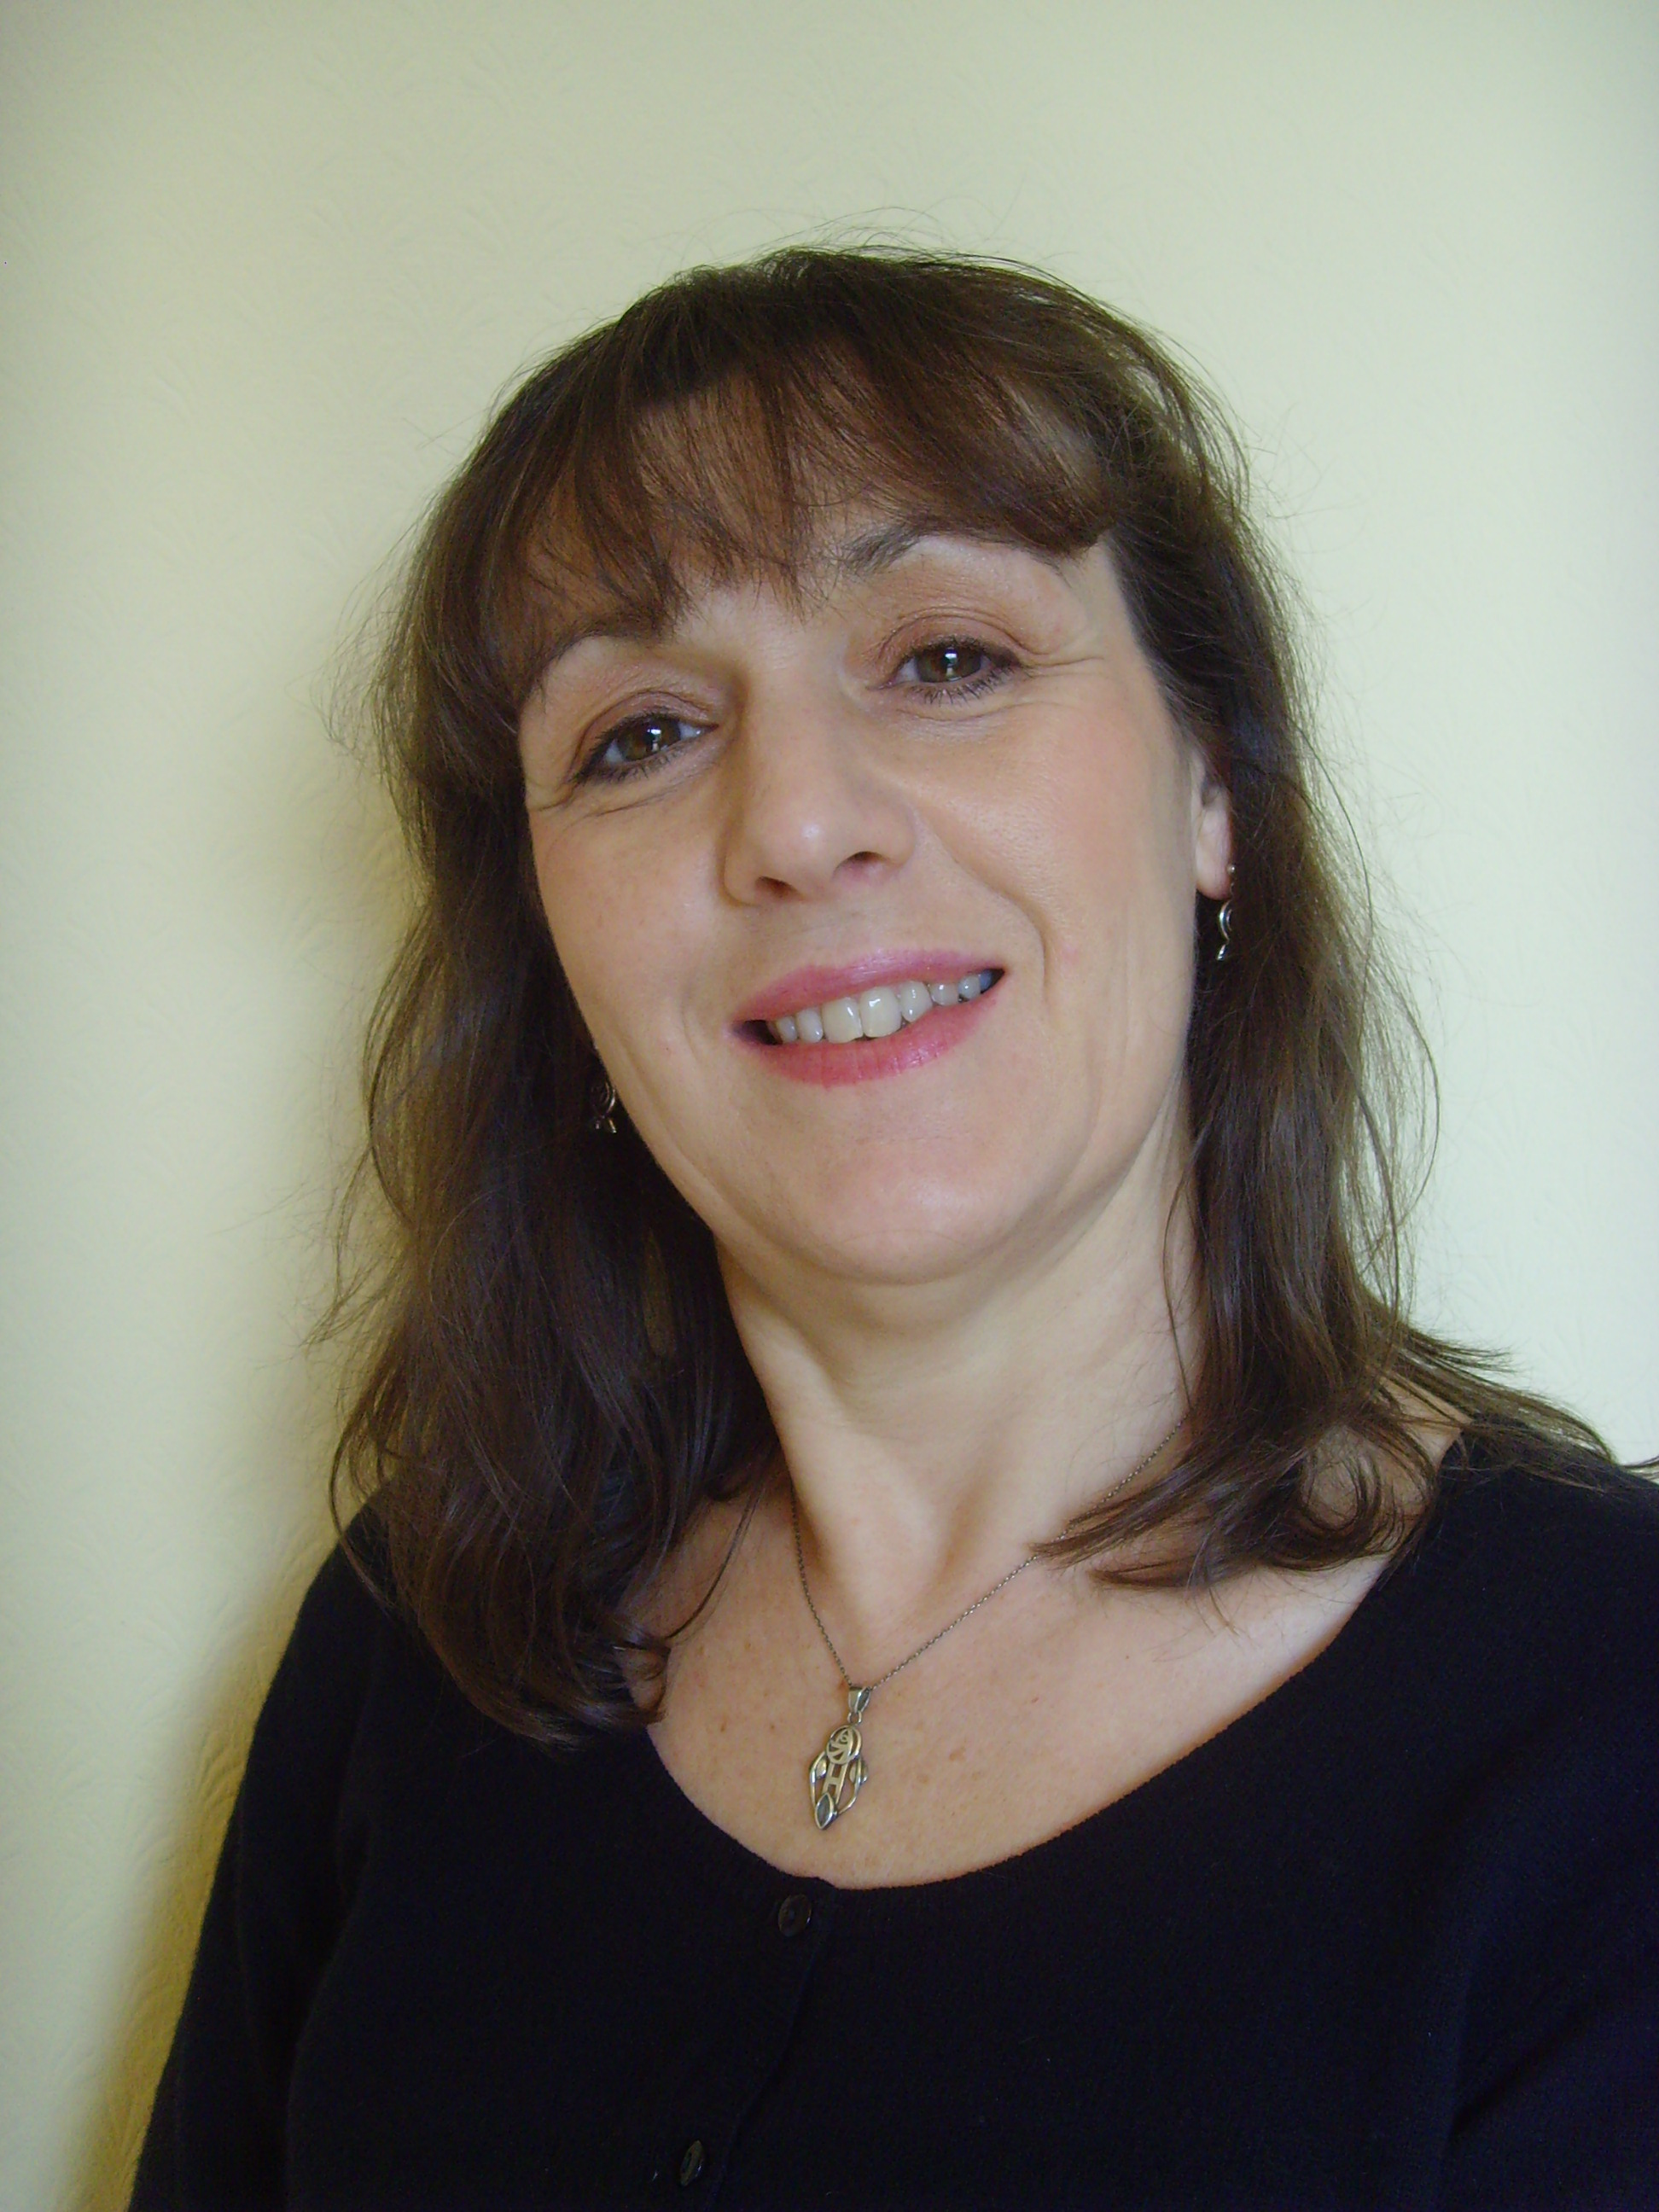
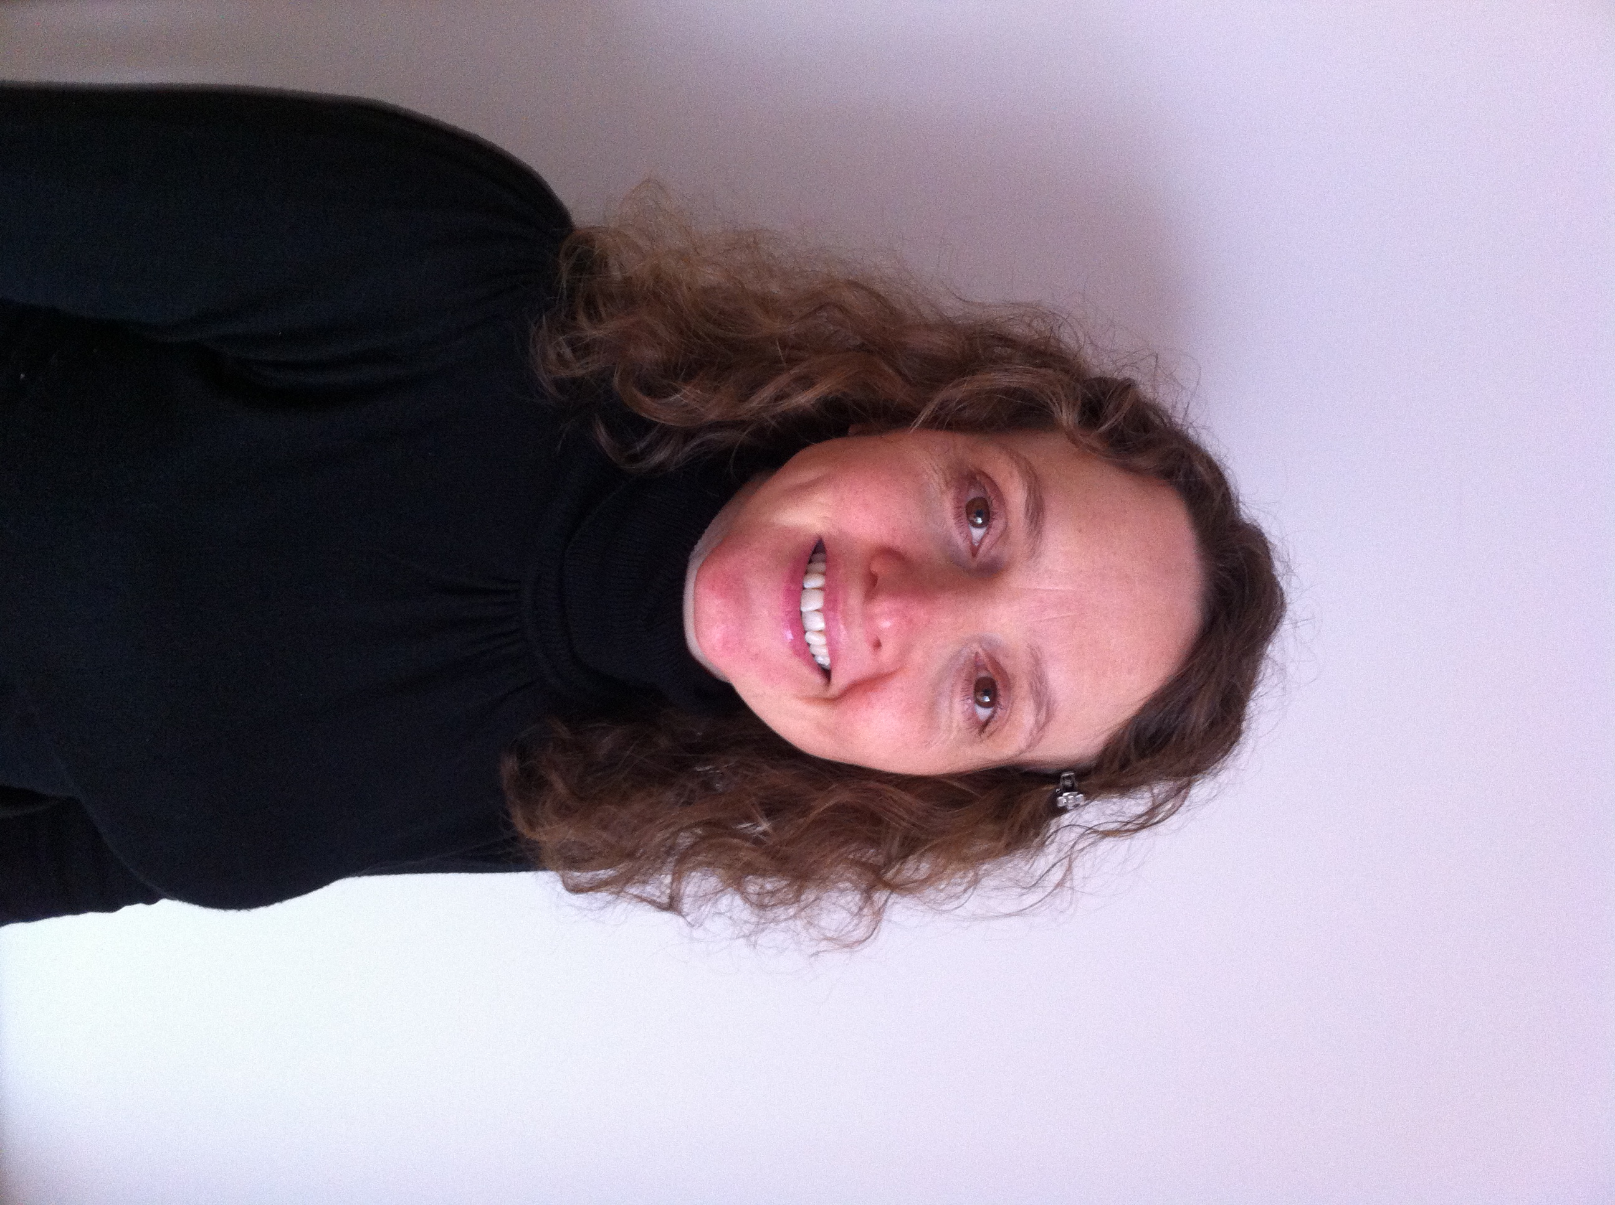

Stephanie Hastings


Stephanie Hastings is a Cognitive Behavioural Therapist and a Trainer in training with the British Isles DBT training team. Stephanie qualified as a Social Worker in 1991 and has worked for Local Authorities Children and Family Services, the NSPCC (Sexual Abuse project) before moving to work in Health Services in North Wales in 2003.

Stephanie is now employed as a CBT therapist (BABCP accredited practitioner) in a tier 3 Community CAMHS in North Wales delivering CBT, training and supervising others in CBT, and is an honorary lecturer at Bangor University.

Stephanie trained in DBT in 2007 and completed the Post Graduate Certificate in DBT in 2012. She is the lead for a CAMHS DBT programme which has been running for 10 years and is currently a research therapist in a large RCT of DBT for Treatment Resistant Depression led by Professor Tom Lynch at Southampton University.

